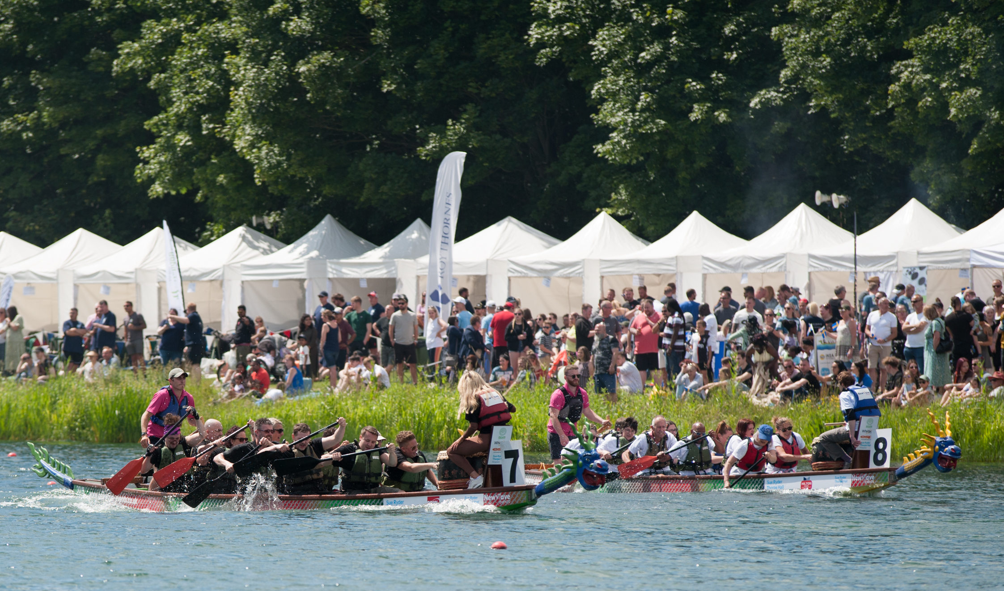
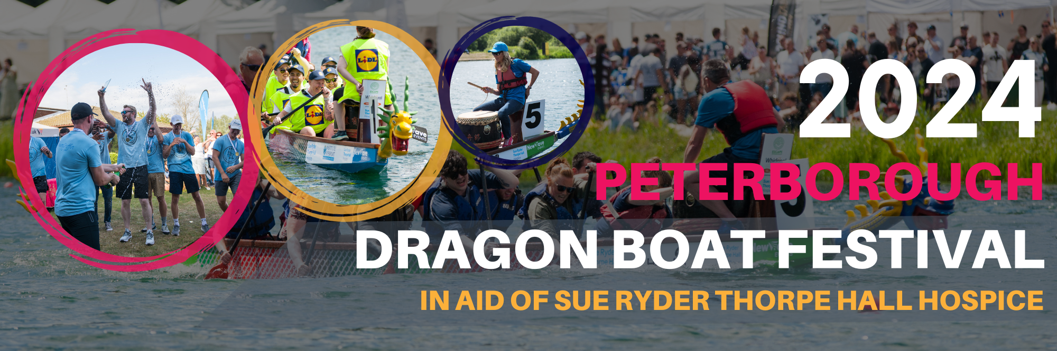
Crew Gazebos
Back by popular demand, crew gazebos are again available for hire. Each high quality unit measures 3m x 3m and comes complete with 12 chairs (more are available on request).

The gazebos will be situated in a good position on the Rowing Lake overlooking the racecourse and will provide an ideal base for your crew as well as shelter in case of inclement weather (or from the hot sun!)

The gazebos will be delivered and erected for you before the event and taken away at the end and all come with your company name board attached. We have managed to negotiate an excellent rate with our supplier and are providing them at cost plus a small administration fee.

Gazebos will be allocated on a first come, first served basis (max one gazebo per team entry) on receipt of the completed booking form below together with appropriate payment.

Please note that crews may bring their own gazebos but space will only be allocated after the paid gazebos by the start.

Crew Gazebo Booking Form
Company name
Crew name
Crew manager/contact
Contact tel no | Contact email
I wish to book * crew gazebo(s) (*please indicate number required)

£220 + vat (£264.00) per gazebo payable to NWave Events Ltd

I accept responsibility for the equipment hired during the hire period 9am – 6pm and will make good any loss or damage

Signed | Date
Please send your completed form to dragonboatevents@newwave-events.co.uk and we will send you an invoice for payment.

*Payment may also be made by credit or debit card (2% transaction charge) or cheque. Please inform us if you wish to pay by card or cheque when emailing the form.
You can also book via the online booking form https://dragonboatevents.co.uk/peterborough-dragon-boat-festival/

